**1.Write a program to implement class Employee.**

import java.util.*;

class Employee

{

int emp_id;

String emp_name;

float emp_salary;

void getdata()

{

Scanner sc=new Scanner(System.in);

System.out.println("Enter id,name and salary of Employee:");

emp_id=sc.nextInt();

emp_name=sc.next();

emp_salary=sc.nextFloat();

}

void putdata()

{

System.out.println("Employee Id="+emp_id);

System.out.println("Employee Name="+emp_name);

System.out.println("Employee Salary="+emp_salary);

}

public static void main(String args[])

**{**

Employee e=new Employee();

e.getdata();

e.putdata();

}

}

**Output :-**

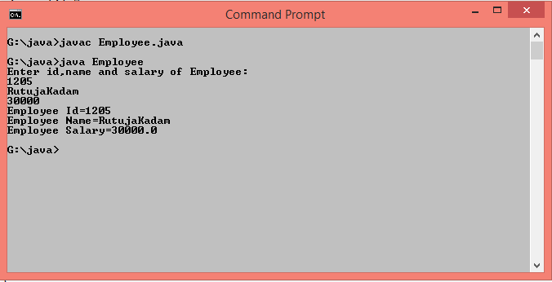

**2.Write a program to define Date class consisting of day,month and year as data members.Write a function which compaires two different dates.**

import java.util.*;

class Date

{

int d1,d2,m1,m2,y1,y2;

void getdata()

{

Scanner sc=new Scanner(System.in);

System.out.println("Enter details of 1st date");

System.out.println("Enter day,month and year(like 31 1 2000)");

d1=sc.nextInt();

m1=sc.nextInt();

y1=sc.nextInt();

System.out.println("Enter details of 2nd date");

System.out.println("Enter day,month and year(like 31 1 2000)");

d2=sc.nextInt();

m2=sc.nextInt();

y2=sc.nextInt();

}

void compare()

{

if(d1==d2&&m1==m2&&y1==y2)

System.out.println("Dates are equal");

else

System.out.println("Dates are not equal");

}

public static void main(String args[])

{

Date d=new Date();

d.getdata();

d.compare();

}

}

**Output :**-

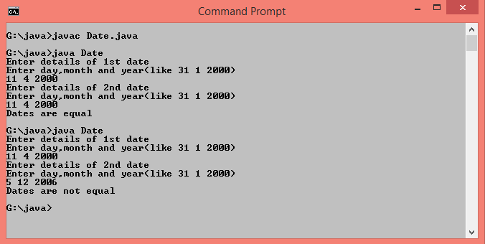

**3.Write a program to calculate area of rectangle ,circle and triangle using function overloading.**

class FunctionOverloading

{

double radius,length,breadth,base,height;

void area(int r)

{

radius=r;

System.out.println("Area of Circle="+(3.14*radius*radius)+" Sq.unit");

}

void area(int l,int b)

{

length=l;

breadth=b;

System.out.println("Area of Rectangle="+(length*breadth)+" Sq.unit");

}

void area(double b,double h)

{

base=b;

height=h;

System.out.println("Area of Triangle="+(0.5*base*height)+" Sq.unit");

}

public static void main(String args[])

{

FunctionOverloading f=new FunctionOverloading();

f.area(5);

f.area(5,2);

f.area(4.2,4.0);

}

}

**Output:-**

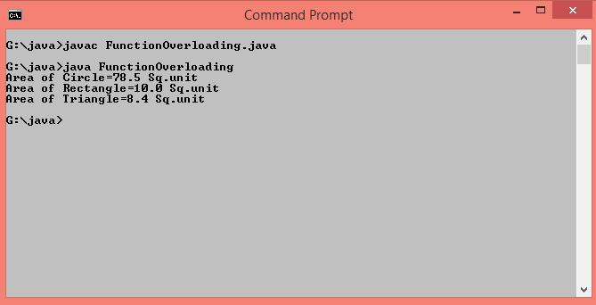

**4.Write a program to calculate an average of 3 integers,4 floats and 1 array of 15 integers using function overloading**.

class Average

{

void calculate(int num1,int num2,int num3)

{

System.out.println("Average of Integers="+((num1+num2+num3)/3));

}

void calculate(double num1,double num2,double num3,double num4)

{

System.out.println("Average of Float="+((num1+num2+num3+num4)/4));

}

void calculate(int arr[])

{

int total=0;

for(int i=0;i<15;i++)

{

total=total+arr[i];

}

System.out.println("Average of Array="+(total/15));

}

public static void main(String args[])

{

int arr[]={1,2,3,4,5,6,7,8,9,10,11,12,13,14,15};

Average a=new Average();

a.calculate(30,15,17);

a.calculate(40.6,35.7,50.0,15.3);

a.calculate(arr);

}

}

**Output :-**

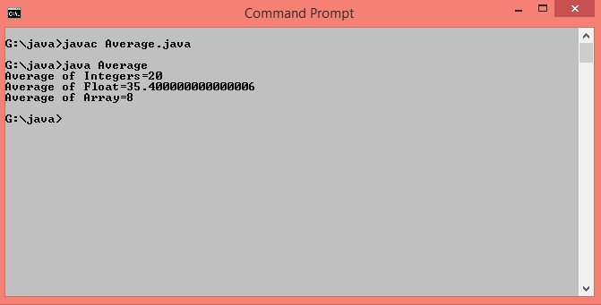

**5.Write a program to find maximum number among 3 integers,2 floats using function overloading.**

class MaxNum

{

int calculateMax(int num1,int num2,int num3)

{

if(num1>num2&&num1>num3)

return num1;

else if(num2>num1&&num2>num3)

return num2;

else

return num3;

}

double calculateMax(double num1,double num2)

{

if(num1>num2)

return num1;

else

return num2;

}

public static void main(String args[])

{

MaxNum m=new MaxNum();

int maxint=m.calculateMax(5,2,7);

double maxdouble=m.calculateMax(4.2,4.0);

if(maxint>maxdouble)

System.out.println("Max Number is "+maxint);

else

System.out.println("Max Number is "+maxdouble);

}

}

**Output :-**

